**Pemrogramman 4**

**Praktikum 2**

**Nama : Muhammad Sidratul Muntaha**

**NMP : 4510210013**

**berikut adalah tampilan untuk compile dan menjalankan tomcat**

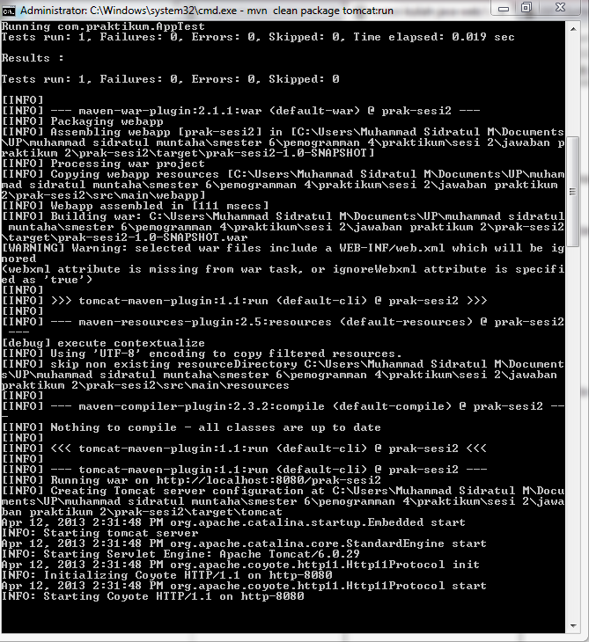

**Tampilan web**

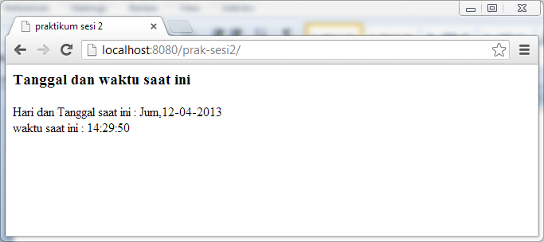

**tampilan web dengan form**

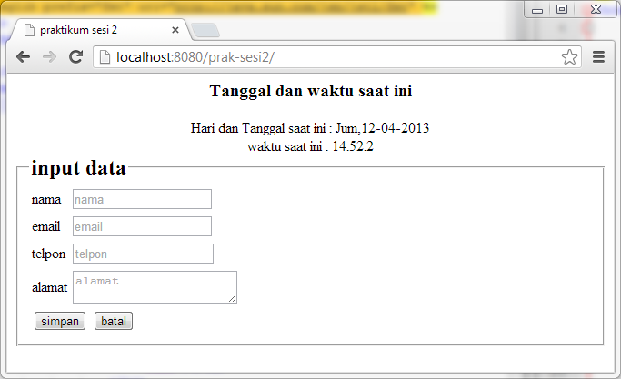

**input data pada form**

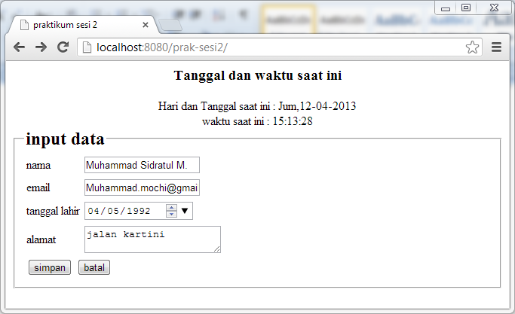

**source code**

|  |
| --- |
| <%@ taglib prefix="c" uri="http://java.sun.com/jsp/jstl/core" %>  <%@ taglib prefix="fmt" uri="http://java.sun.com/jsp/jstl/fmt" %>  <html>  <head>  <title>praktikum sesi 2</title>  </head>  <body>  <time align="center">  <h3>Tanggal dan waktu saat ini</h3>  <c:set var="now" value="<%=new java.util.Date()%>"/>  <div>Hari dan Tanggal saat ini :  <fmt:formatDate pattern="E,dd-MM-yyyy" value="${now}"/>  </div>  <div>waktu saat ini : <fmt:formatDate pattern="H:m:s" value="${now}"/></div>  </time>  <form method="post" action="verifikasi.jsp">  <fieldset>  <legend><h2>input data</h2></legend>  <table>  <tr>  <td>nama</td>  <td><input type="text" name="nama" placeholder="nama"></td>  </tr>  <tr>  <td>email</td>  <td><input type="email" name="email" placeholder="email"></td>  </tr>  <tr>  <td>tanggal lahir</td>  <td><input type="date" name="tl" placeholder="tanggal lahir"></td>  </tr>  <tr>  <td>alamat</td>  <td><textarea name="alamat" placeholder="alamat"></textarea></td>  </tr>  <tr>  <td colspan="2">  <input type="submit" value="simpan"/>  <input type="reset" value="batal"/>  </td>  </tr>  </table>  </fieldset>  </form>  </body>  </html> |

**menampilkan parameter yang dikirim**

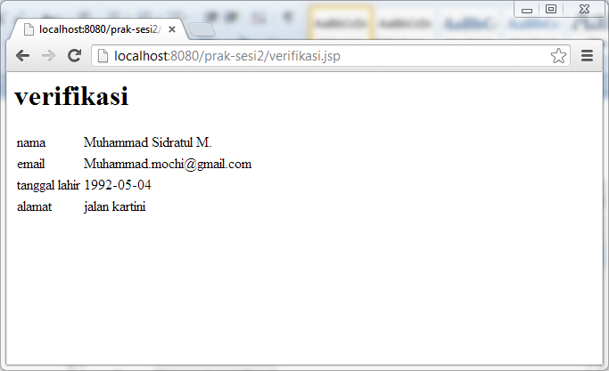

**source code**

|  |
| --- |
| <%@ taglib prefix="c" uri="http://java.sun.com/jsp/jstl/core" %>  <h1>verifikasi</h1>  <html lang="id">  <head>  </head>  <body>  <table>  <tr>  <td>nama</td>  <td><%= request.getParameter("nama") %></td>  </tr>  <tr>  <td>email</td>  <td><%= request.getParameter("email") %></td>  </tr>  <tr>  <td>tanggal lahir</td>  <td><%= request.getParameter("tl") %></td>  </tr>  <tr>  <td>alamat</td>  <td><%= request.getParameter("alamat") %></td>  </tr>  </table>  </body>  </html> |

**database p4 dan tabel produk**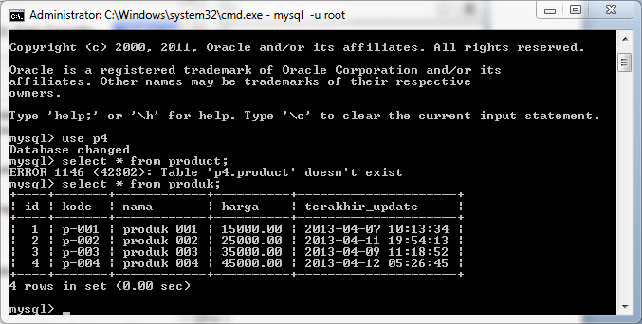

**menampilkan field pada tabel produk**

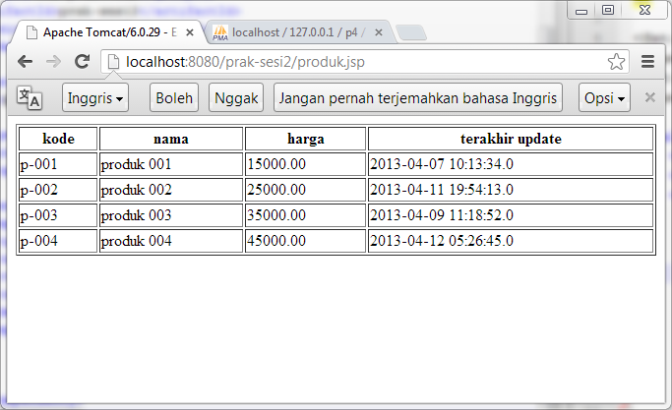

**Source code**

|  |
| --- |
| <%@ page import="java.io.*,java.util.*,java.sql.*"%>  <%@ taglib uri="http://java.sun.com/jsp/jstl/core" prefix="c"%>  <%@ taglib uri="http://java.sun.com/jsp/jstl/sql" prefix="sql"%>  <html lang="id">  <head></head>  <body>  <sql:setDataSource var="db" driver="com.mysql.jdbc.Driver" url="jdbc:mysql://localhost/p4" user="root" password=""/>    <sql:query dataSource="${db}" var="hasil">SELECT * from produk;</sql:query>    <table border="1" width="100%">  <tr>  <th>kode</th>  <th>nama</th>  <th>harga</th>  <th>terakhir update</th>  </tr>  <c:forEach var="data" items="${hasil.rows}">  <tr>  <td><c:out value="${data.kode}"/></td>  <td><c:out value="${data.nama}"/></td>  <td><c:out value="${data.harga}"/></td>  <td><c:out value="${data.terakhir_update}"/></td>  </tr>  </c:forEach>  </table>  </body>  </html> |